**Team Number: 11**

**NAME** **ROLL NUMBER**

K LEELA PRASANNA LAKSHMI - 315126510188

N DEEPTHI LAVANYA - 315126510184

K NARAYANA MURTHY - 315126510198

KANDULA VENKATESH - 315126510209

**ANITS BLOOD BANK**

**ABSTRACT**

The purpose of this project is to develop an “**Anits Blood bank**” system to assist in the management of blood donor records and ease control the distribution of blood for the required individual demands. Within quick and timely access to donor records, creating market strategies for blood donation, lobbying and sensitization of blood donors becomes very difficult. The blood bank system offers functionalities to quick access to donor records collected from various branches of our college & also supports all the functionalities of blood bank. It is used for maintaining information about the campus. The project includes three main modules admin, donor, and acceptors.

**Content:**

1. Introduction
2. Motivation,
3. Proposed work,
4. Block diagram/ DFD diagram of proposed work,
5. Principles to conduct your experiments,
6. Conclusions,
7. Resources to be used.

**Introduction**

**ANITS BLOOD BANK** is specially meant for NRI hospital who need blood for their patient regularly or for blood bank who collect blood to be given for different hospital. Here we maintain the information about the donor who are in our collage. It helps the doctors to find the donor at right time.

We have tried to maintain all those information of our students which is easily understandable to the doctors which makes them easy to find the donor. Using these schema donor to be attracted to donate the blood. Our system encourages the blood communication between the donor and doctor product is delivered within time and delays are minimized. Proper tools are used which requires low cost for the development of our system.

Motivation

**Proposed work:**

**DFD diagram of proposed work:**

**Context Level - DFD:**

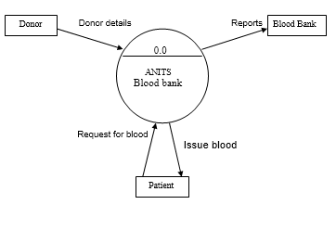

Level 1:

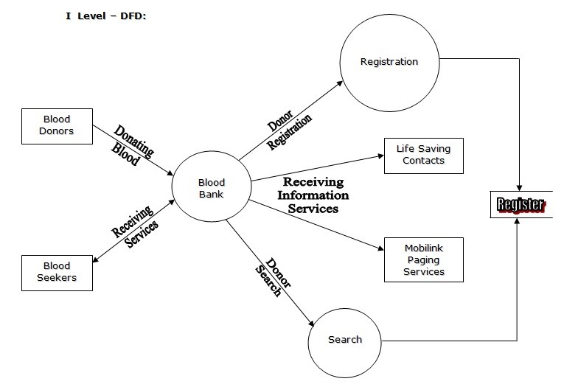

Level 2:

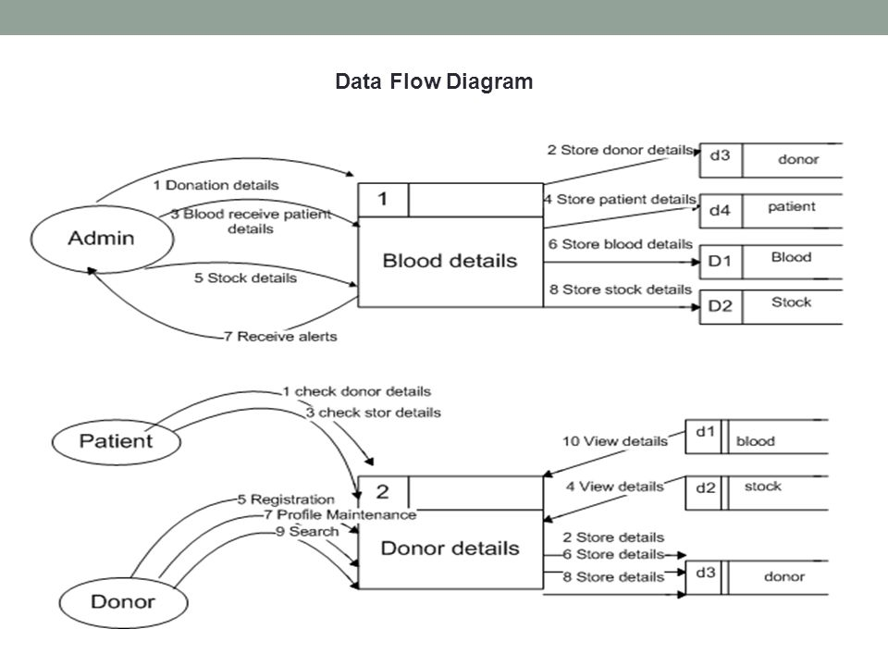

Principles to conduct your experiments:

**Conclusions:**

* The application will be coded using languages as :

PHP, JavaScript, html, CSS.

* The main objective of blood bank is to develop an emergency application for people who needs blood by using this system.

**Resources to be used:**